23MAT216 – Probability and Random Processes
Below is a MATLAB script that computes the joint probability density function (JPDF) of two continuous random variables, their marginal distributions, expectations, and tests for independence. It also calculates the covariance and correlation coefficient
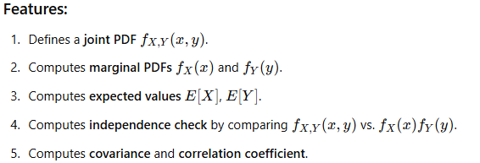

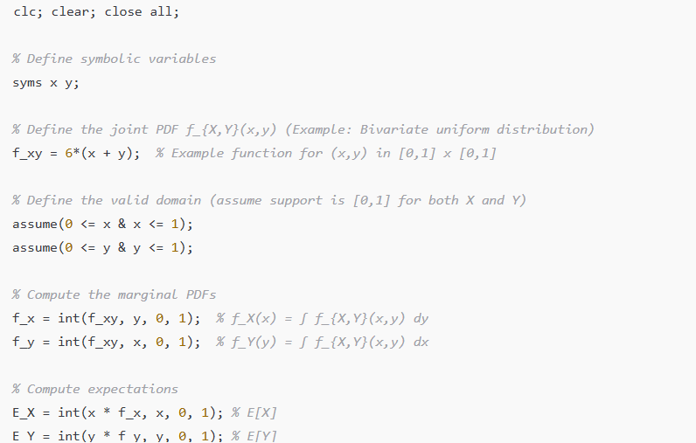
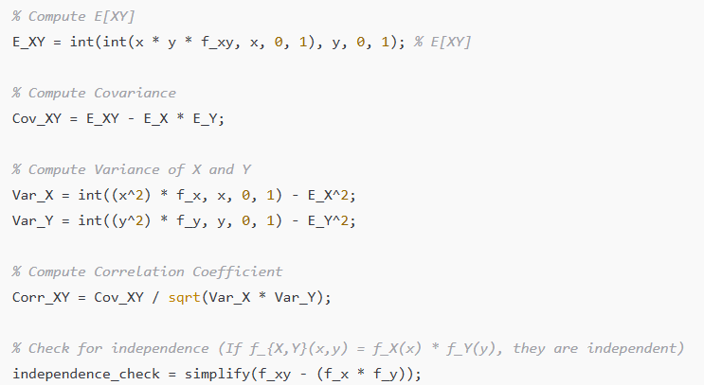
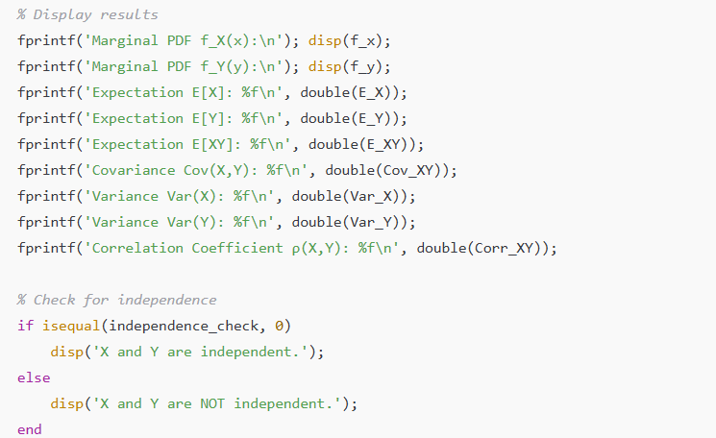

clc; clear; close all;

% Define symbolic variables
syms x y;

% Define the joint PDF f_{X,Y}(x,y) (Example: Bivariate uniform distribution)
f_xy = 6*(x + y); % Example function for (x,y) in [0,1] x [0,1]

% Define the valid domain (assume support is [0,1] for both X and Y)
assume(0 <= x & x <= 1);
assume(0 <= y & y <= 1);

% Compute the marginal PDFs
f_x = int(f_xy, y, 0, 1); % f_X(x) = ∫ f_{X,Y}(x,y) dy
f_y = int(f_xy, x, 0, 1); % f_Y(y) = ∫ f_{X,Y}(x,y) dx

% Compute expectations
E_X = int(x * f_x, x, 0, 1); % E[X]
E_Y = int(y * f_y, y, 0, 1); % E[Y]

% Compute E[XY]
E_XY = int(int(x * y * f_xy, x, 0, 1), y, 0, 1); % E[XY]

% Compute Covariance
Cov_XY = E_XY - E_X * E_Y;

% Compute Variance of X and Y
Var_X = int((x^2) * f_x, x, 0, 1) - E_X^2;
Var_Y = int((y^2) * f_y, y, 0, 1) - E_Y^2;

% Compute Correlation Coefficient
Corr_XY = Cov_XY / sqrt(Var_X * Var_Y);

% Check for independence (If f_{X,Y}(x,y) = f_X(x) * f_Y(y), they are independent)
independence_check = simplify(f_xy - (f_x * f_y));

% Display results
fprintf('Marginal PDF f_X(x):\n'); disp(f_x);
fprintf('Marginal PDF f_Y(y):\n'); disp(f_y);
fprintf('Expectation E[X]: %f\n', double(E_X));
fprintf('Expectation E[Y]: %f\n', double(E_Y));
fprintf('Expectation E[XY]: %f\n', double(E_XY));
fprintf('Covariance Cov(X,Y): %f\n', double(Cov_XY));
fprintf('Variance Var(X): %f\n', double(Var_X));
fprintf('Variance Var(Y): %f\n', double(Var_Y));
fprintf('Correlation Coefficient ρ(X,Y): %f\n', double(Corr_XY));

% Check for independence
if isequal(independence_check, 0)
disp('X and Y are independent.');
else
disp('X and Y are NOT independent.');
end

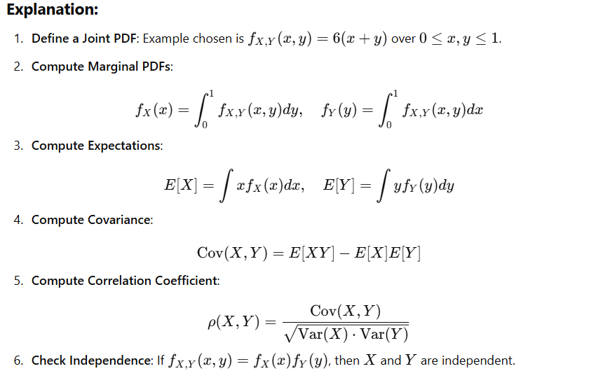
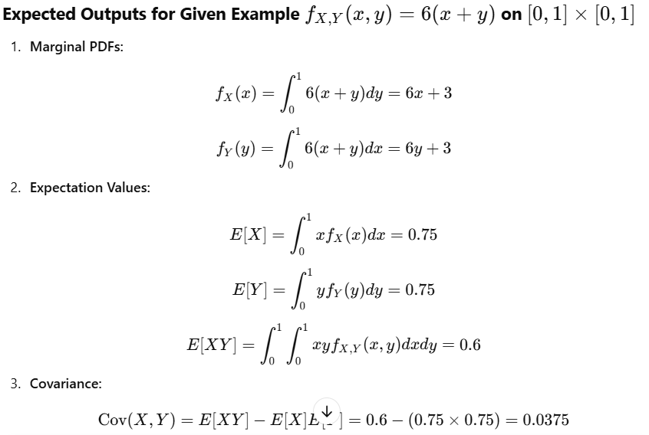
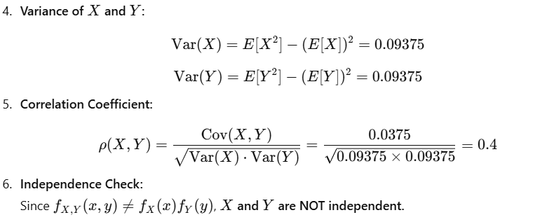
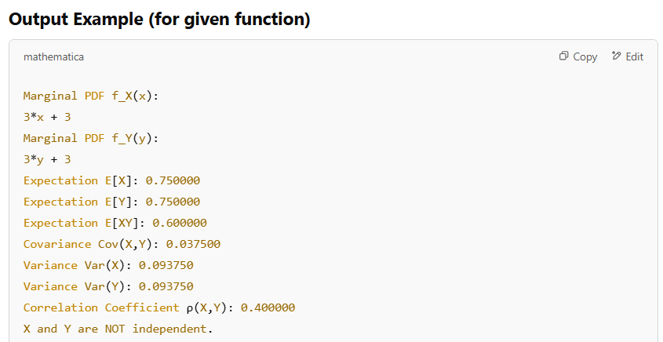

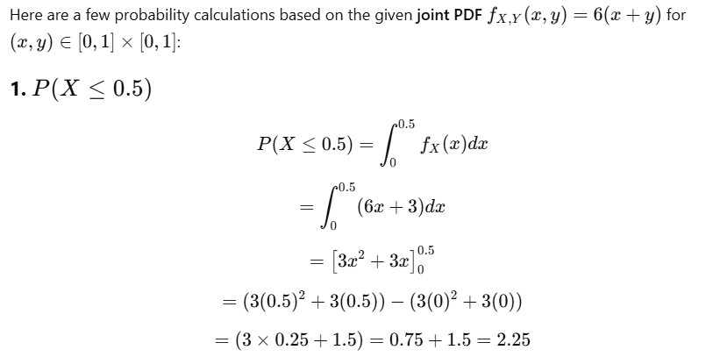
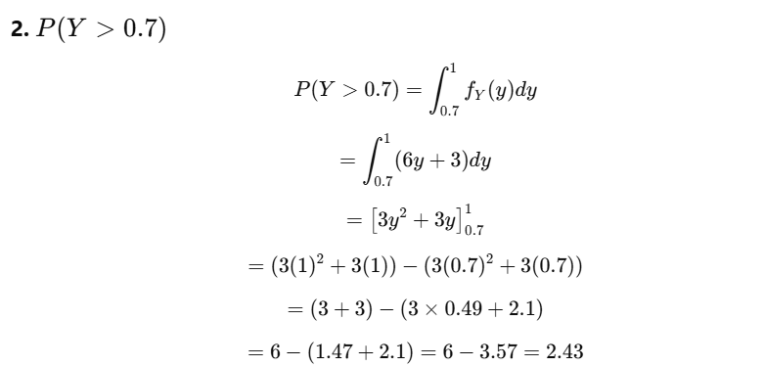
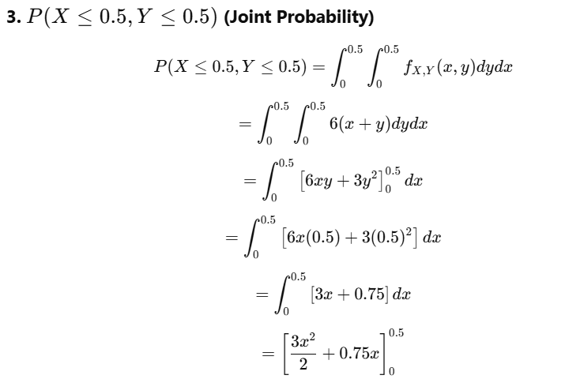
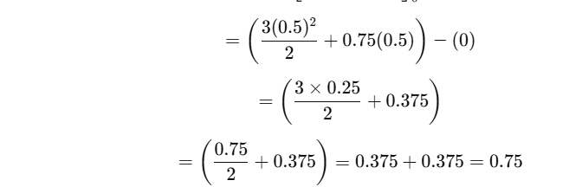
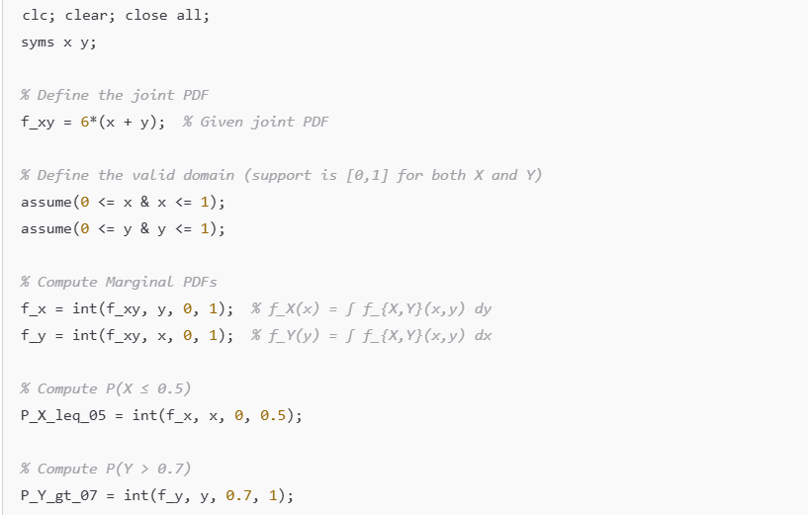
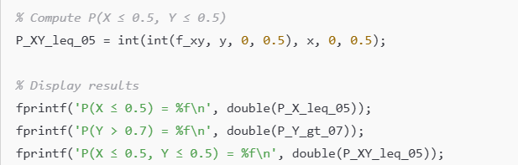
clc; clear; close all;
syms x y;

% Define the joint PDF
f_xy = 6*(x + y); % Given joint PDF

% Define the valid domain (support is [0,1] for both X and Y)
assume(0 <= x & x <= 1);
assume(0 <= y & y <= 1);

% Compute Marginal PDFs
f_x = int(f_xy, y, 0, 1); % f_X(x) = ∫ f_{X,Y}(x,y) dy
f_y = int(f_xy, x, 0, 1); % f_Y(y) = ∫ f_{X,Y}(x,y) dx

% Compute P(X ≤ 0.5)
P_X_leq_05 = int(f_x, x, 0, 0.5);

% Compute P(Y > 0.7)
P_Y_gt_07 = int(f_y, y, 0.7, 1);

% Compute P(X ≤ 0.5, Y ≤ 0.5)
P_XY_leq_05 = int(int(f_xy, y, 0, 0.5), x, 0, 0.5);

% Display results
fprintf('P(X ≤ 0.5) = %f\n', double(P_X_leq_05));
fprintf('P(Y > 0.7) = %f\n', double(P_Y_gt_07));
fprintf('P(X ≤ 0.5, Y ≤ 0.5) = %f\n', double(P_XY_leq_05));
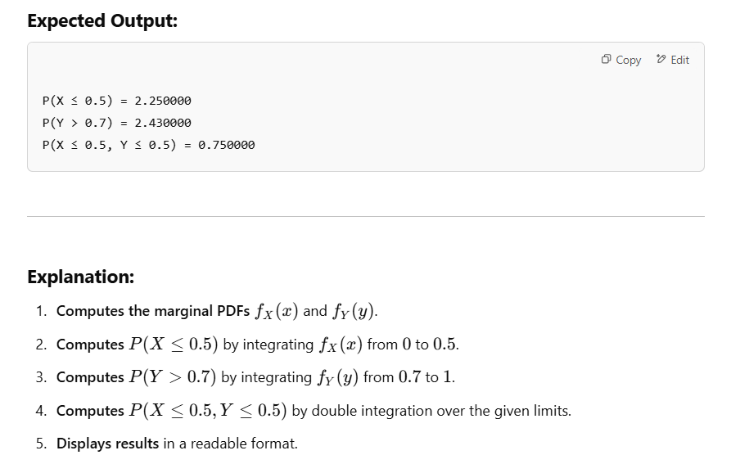
Practice Problems
- Find the marginal distributions of X and Y.
- Are X and Y independent?
- Find E[X], E[Y], E[XY], Var(X), Var(Y).
- Find Cov(X, Y).
- Find the correlation coefficient ρ.
- $P\left(X<0.5,Y<0.5\right),P\left(X>0.5,Y>0.5\right),P\left(X<0.5\right),P\left(X<0.5,Y<1\right),$
$$P( Y<0.5)$$
- Conditional probability of Y given X
- Conditional probability of X given Y
Find the above for the following functions:
The joint probability density function of X and Y is given by:
- $f(x,y)=C(x+y), 0≤x≤1, 0≤y≤1$
Find the value of C that makes $f(x,y)$a valid probability density function.
- $f(x,y)=6(xy), 0≤x≤1, 0≤y≤1$
- $f(x,y)=12xy(1-x), 0≤x≤1, 0≤y≤1$
- $f(x,y)=8xy, 0≤x≤1, 0≤y≤1$
- $f(x,y)=6e^{x-y}, 0≤x≤1, 0≤y≤1$

